RUNNING TOMCAT-9 SERVER INSIDE A CONTAINER:

Step1:

Pull a tomcat official image from the online registry.

# docker pull tomcat:9.0.27

Step2:

Check the image available in your local machine.

# docker images

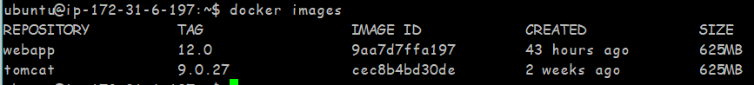

Step3:

Run this image in distach mode and also give a name and port number to the container.

# docker run -d -p 8080:8080 --name testtomcat5 tomcat:9.0.27

Check the status of the running container.

# docker ps

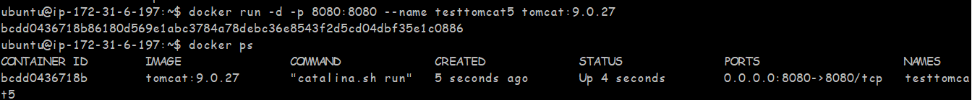

Step4:

Run this container in interactive mode and do some changes.

# docker exec -it testtomcat5 bash

C:\Users\uku13\Desktop\image-snip\Capture4.PNG

Step5:

Our container is live with the help of aws otherwise you check with your localhost.

Check-in your web browser.

Search ---> Public Dns of aws :8080

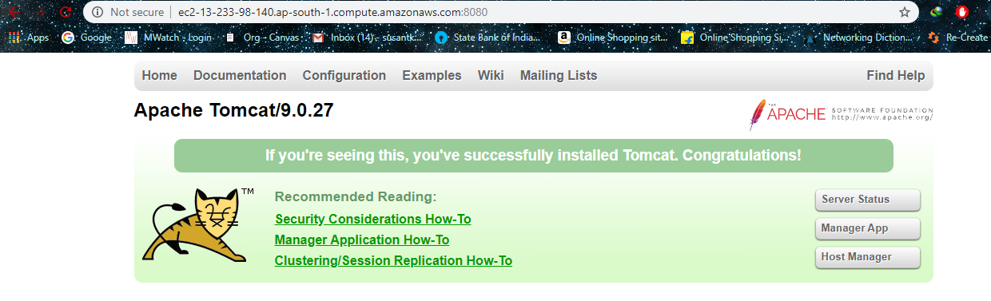

Step6:

Great our tomcat is running successfully.

But we need to put our war file inside the manager app but it is not working. It is looking for user name and password and we don’t have yet so we add inside conf/tomcat-users.xml.

It is a fresh Linux so there is no vi editor available so we need to install it.

# apt-get update

# apt-get install vi

# apt-get install vim

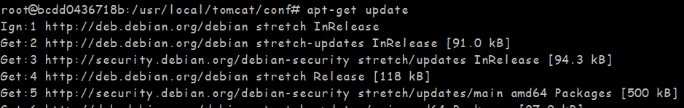

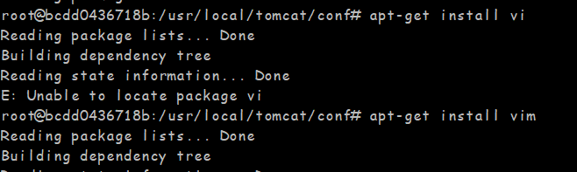

Step7:

Change directory to conf and see tomcat-users.xml file available. Edit this file.



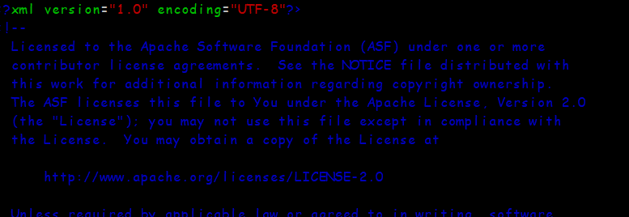

Add our username and password to the user section.

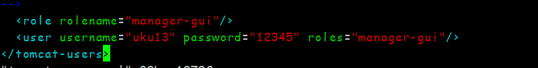

Step8:

Comment out system IP parser to avoid IP conflict.

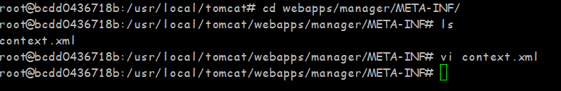



Step9:

Restart your container and you are all set for deployment of the war file.

# docker restart container name /id

C:\Users\uku13\Desktop\image-snip\Capture13.PNG

Go to the browser and type your aws dns:8080

Then go to manage the app and sign in there and deploy your code.

THANK YOU